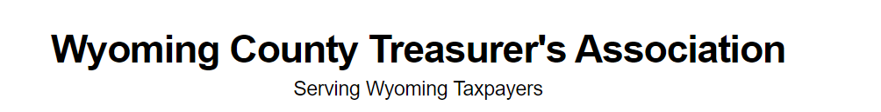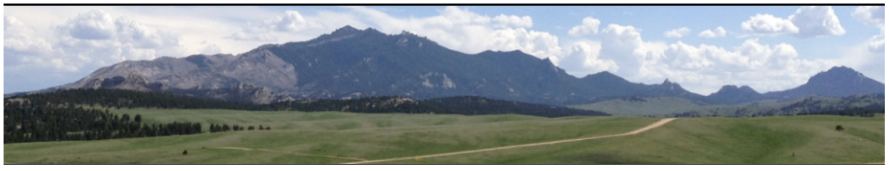

Tuesday, September 26, 2023
8:00 am – 5:00 pm Public Officer Training
5:30 pm – 7:00 pm Natrona County Welcome Reception
The M Building (234 East 1st St)
Transportation will be provided.
Wednesday, September 27, 2023
8:00 am – 10:30 am WACO General Session
10:30 am – 10:45 am Break
10:45 am – 11:15 am WYDOT
Decal discussion, county treasurer’s collecting fees for decals and conservation plate renewal. Discussion on PLT fees and RIS. Discussion on EV fees from legislative committee meeting in August.
11:15 am – 12:00 pm DOR
Updates and information from the DOR
12:00 pm – 1:00 pm Lunch
Guest Speaker-Former Governor Dave Freudenthal
1:00 pm -1:15 pm Break
1:15 pm – 2:15 pm Representative JT Larson, Legislative Bill discussion
24LSO-0035 Vehicle Registration e-certificate and grace period.
24LSO-0038 School finance-dates for fund transfers
Discuss drawing up a bill changing or adjusting requirements for newspaper advertising adjusting recaptured cost for advertising.
2:15 pm – 3:15 pm Representative Ken Chestek, Legislative Bill discussion
Discussing proposal on bringing a bill that removes party affiliation for county elected officials.
3:30 pm -5:00 pm Tour of the National Historic Trails Center
1501 N Poplar St, Casper
6:00 pm – 7:30 pm Dinner at the Wyoming’s Rib & Chop House
256 S Center St, Casper (Paid for by Sponsorship of Jonah Energy)
Thursday, September 28, 2023
8:00 am – 9:30 am WACO General Session
9:30 am – 9:45 am Break
9:45 am – 10:30 am WACO General Session
Guest Speaker – Seth Jahn
10:30 am – 11:30 am Stable Token Discussion
Wyoming Gov. Mark Gordon, Senator Chris Rothfuss, and Wyoming State Treasurer Curt Meier
11:30 am – 12:00 pm WCTA Business Meeting
CALL TO ORDER
- ROLL CALL:
- READING OF LAST YEARS MINUTES
- APPROVAL OF MINUTES
- READING OF FINANCIAL REPORT
- APPROVAL OF FINANCIAL REPORT
- NEW BUSINESS
- ELECTION OF OFFICERS
- OLD BUSINESS
- MEETING ADJOURNED
12:00 pm -1:00 pm Lunch
Video Messages from Congressional Delegation
1:00 pm – 1:15 pm Break
1:15 pm – 3:15 pm Mary Martin-UW Extension
The softer side of Leadership- Leading, Managing & Serving:
Fine tuning your finesse and influence in the workplace
3:15 pm -4:00 pm Round table discussion for Treasurers
5:30 pm – 6:30 pm Social Hour
Ramkota Terrace
6:30 pm - WACO Banquet
Ramkota Ballroom
Guest Speaker-Bob Budd
Door Prize Giveaways

